**Step by Step Guide**

This guide will show you how to fix the Audi A4 Glove Box (2000-2006).

This picture shows you the glove box will look like this after fix:

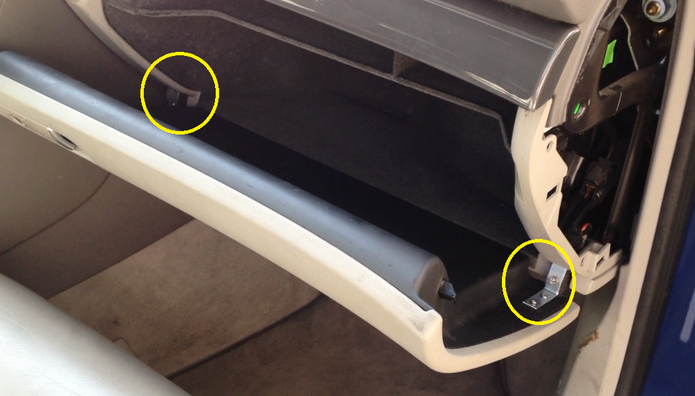

You need prepare:

1. The fix kit which you order at eBay (2 hinge and 8 screws)
2. cross screwdriver (you need prepare yourself)
3. Pen (you need prepare yourself)

All the steps need 30-60 minutes.

Let’s start the fix process:

Step 1. Open the Glove Box cover

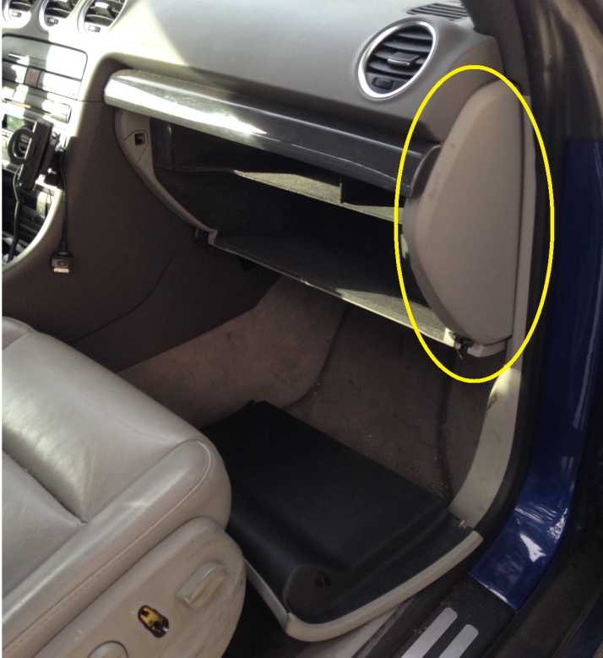

Picture1: Show where is the glove box cover

Use a screw driver or other hard materials, insert here (see Picture 2), to open the cover

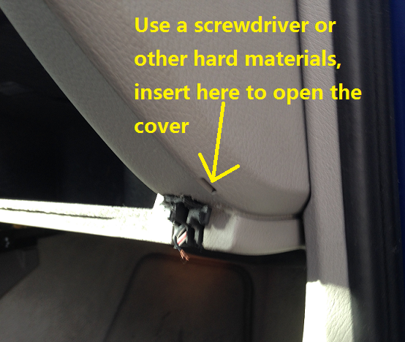 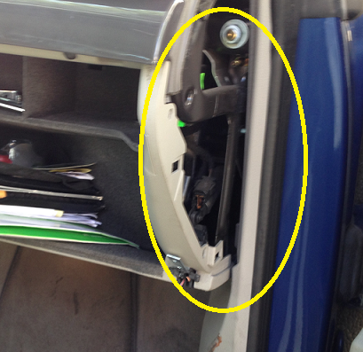

Picture 2: the key hole of cover Picture 3: After open the cover

Step 2. Locating the Screw Hole at the glove box base

For the right side, you need local 2 screw hole. Because the right side is the STRESS surface.

1. Insert the hinge (the bend side is inside) 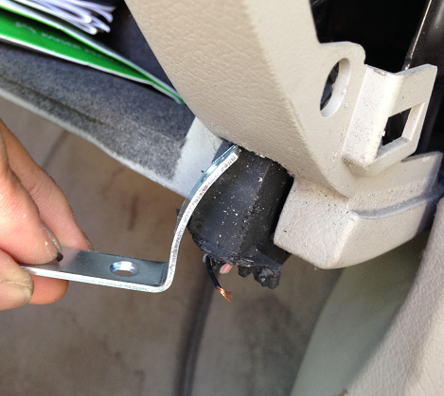

2. Figure out location of the screw, 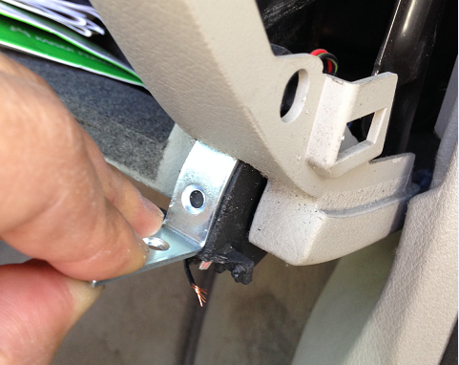.

4. Push as close the glove box, you can

see the second screw location, use pen

to mark the screw location

3. use pen to mark the location

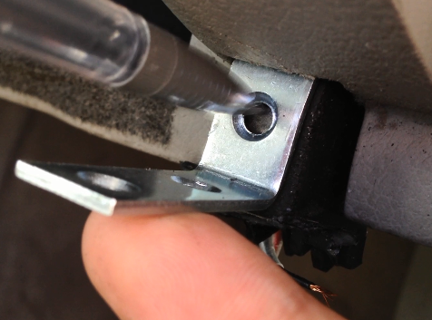 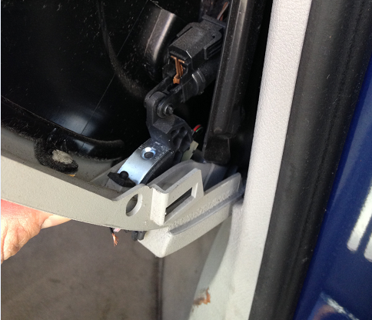

For the Left side, you can chose local only 1 screw hole. Because the left side is not stress surface. The inner screw hole is opinion unless you upen the whole glove box, that need a lot of work. Not suggest to do that.

Locating the screw hole is same operate like the right, no picture need to show how. (there are picture show the left side at next step)

Step 3. Make Screw Hole

After you Locating the screw hole, the next step is drill the screw hole,

You can use electric screwdriver or just screwdriver by hand. It’s easy to drill a hole into the plastic.

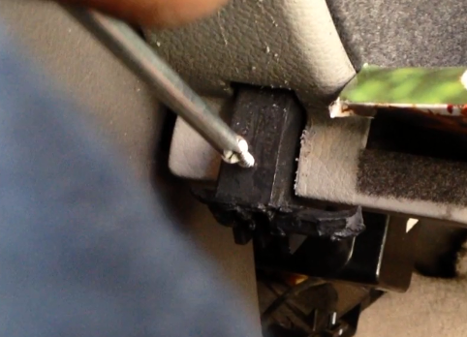

Picture: show drill the screw hole at the left side.

Notice: You can drill with the hinge, but after drill hole, you need take it off the hinge. Because this step only need drill the hole, not install the hinge. Few more step need before hinge install.

Step 4. Locating and drill the Screw at the glove box surface

Below picture show how to locating the screw hole at left side glove box surface

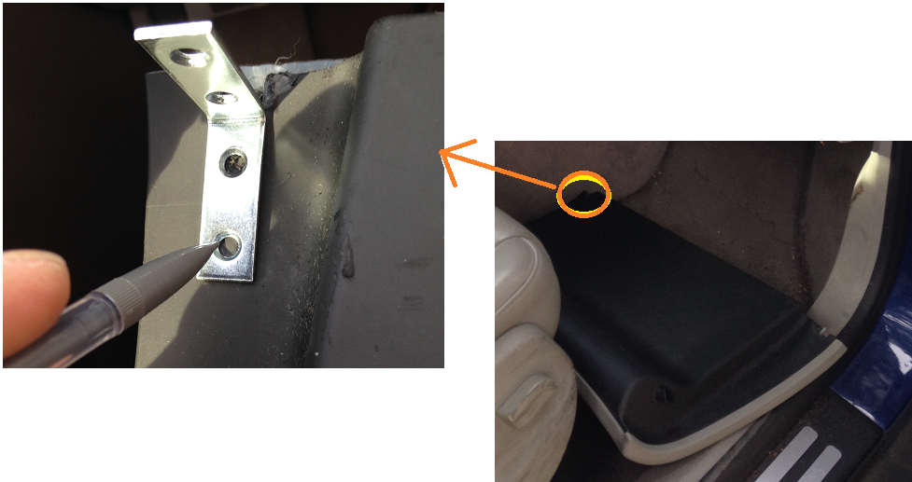

One thing need care about is : the hinge corner need start from the break. please see the yellow arrow at picture below

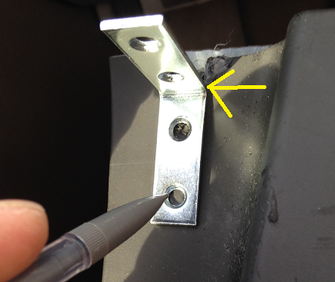

Now you need not only drill hole, you need to install the screws on the glove box surface. (see picture at step 5)

Step 5 (almost done). Install the glove box surface to the base

You had install the screws at the glove box surface at step 4. Now you need install the surface to the base, you need install this screw which shows at the picture below.

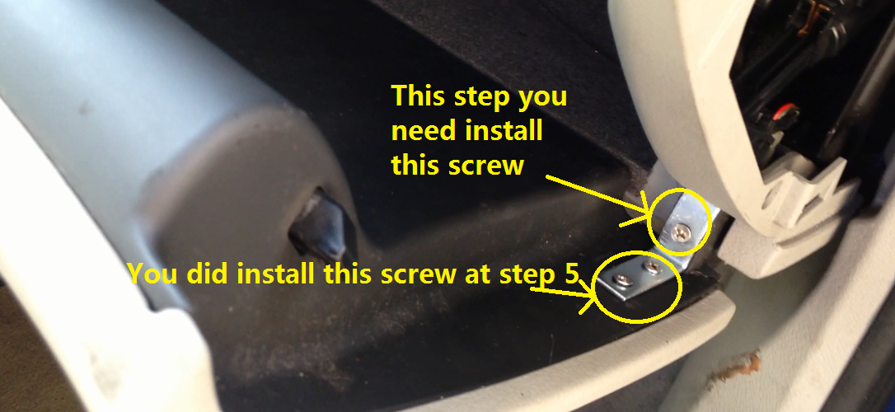

These are same operate at left side.

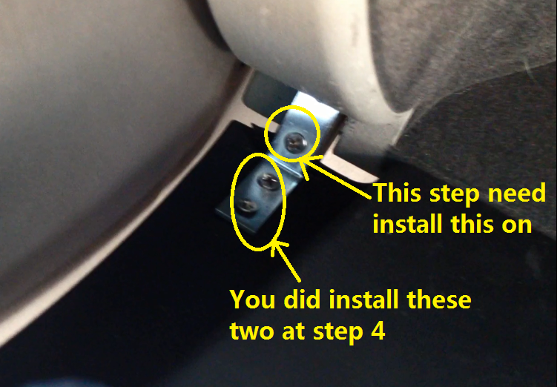

Step 6, Done! Just check is it can close the door

Congratulations, You did a great job. Now you glove box will look like this, just close the door and check is it work.



If have problem to close the door, don’t worry, few selection for quick fix close door issue.

Opinion 1: un-screw and change the screw location.

Opinion 2: disconnect the pressure support. (detail on next page)

**(Opinion Step) Disconnect the pressure support.**

When and why you need disconnect the pressure support?

Because the pressure support is the cured illness of glove box broken, the glove box always broken when you close the door too fast, by the lever principle theory, the hinge will bear too much power, so that’s the reason glove box broken.

If you don’t want broken again after your fix, you can disconnect the pressure support very easy (see the picture below). This only affect the light when you open the glove box only, doesn’t affect other issue, many people chose to disconnect, but this just an opinion. You can decide by yourself.

